Your starting point is the completed version of Exercise 8.3. If you have already closed that file, please reopen it using the Power BI software. You should first complete the previous exercise before starting with this one. If you have just wrapped up the last assignment, your view would probably look like the image below.

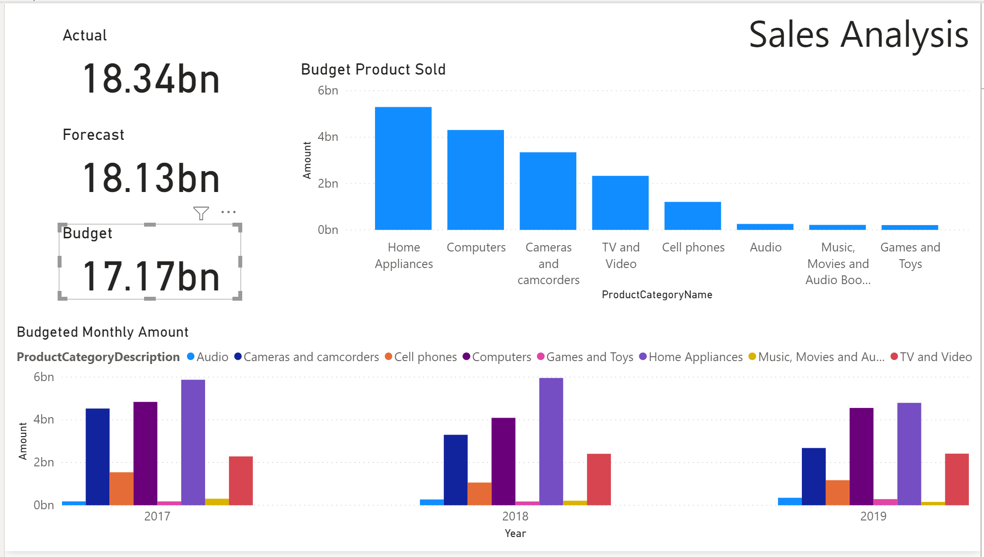

#### Turning off interactions - By default, visualizations on a report page can be used to cross-filter the other visualizations on the page. Sometimes, you want to disable this functionality and keep a chart static regardless of what selections have been made elsewhere in the report. Let us turn off those interactions! Note that you might have to temporarily move a visual to be able to see the circle with the line through it.

#### In this report, we want to make sure the Actual, Forecast, and Budget cards do not change when other elements are selected.

* Select the "Budget Product Sold" visual.

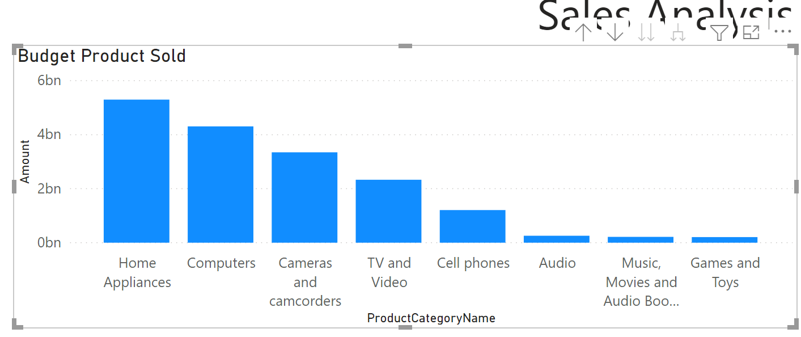

* Go into the interaction editing mode in the *Format* tab at the top of the screen: Format > Edit interactions. 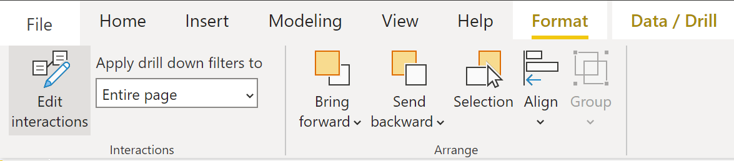



* Note the circle icon at the top-right corner of the Budget Product Sold visual. Move the Sales Analysis text to the left if you cannot see the circle icon.



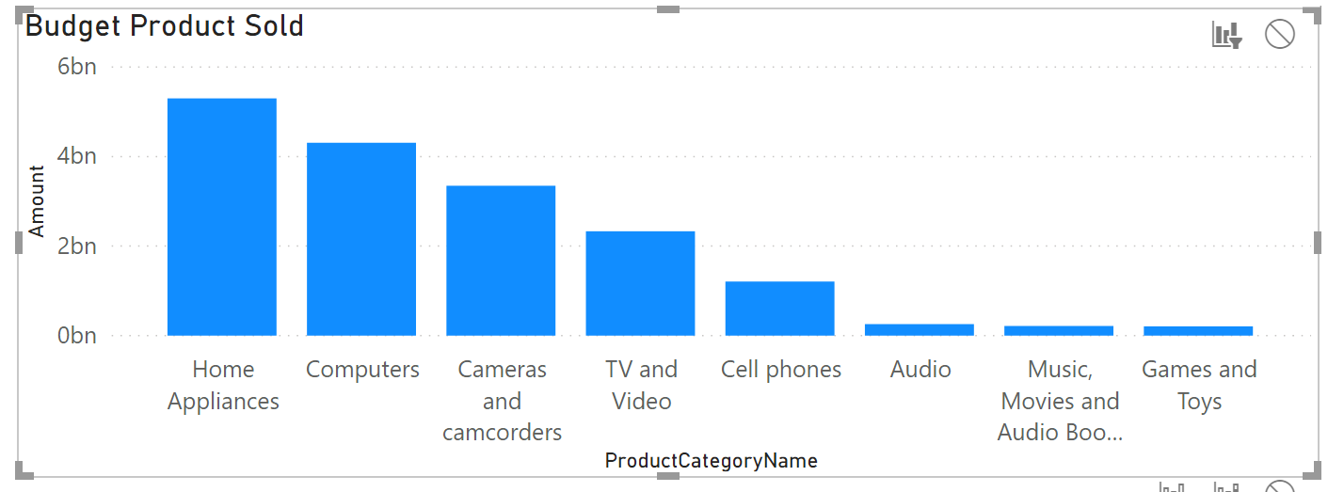



While you are in the Edit interactions mode, this circle icon (representing None interactions) will be present in all visual widgets within the report. You may have to move your visualization object sometimes in order to see the circle icon. The circle icon you see above actually belongs to the Sales Analysis text label box. The currently highlighted widget will not have the circle icon.

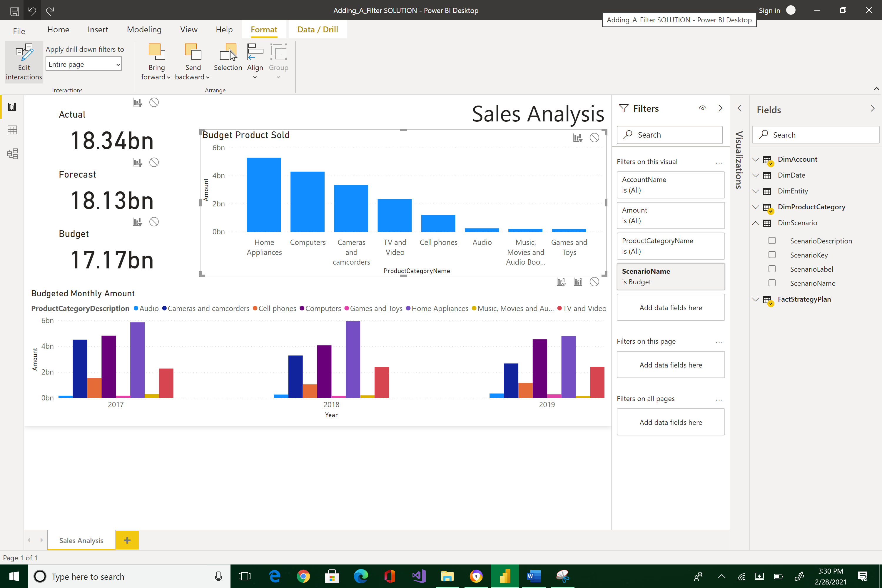



Note that the currently enabled visual widget is the Budget Product Sold column bar chart. Typically, when there is an event that happened in this object such as clicking on a bar, a signal is sent to all the other visuals telling them to update as well.





So, if you do not want a visual to not listen (not interact) to changes taking place from the current enabled widget, click on the None circle icon.

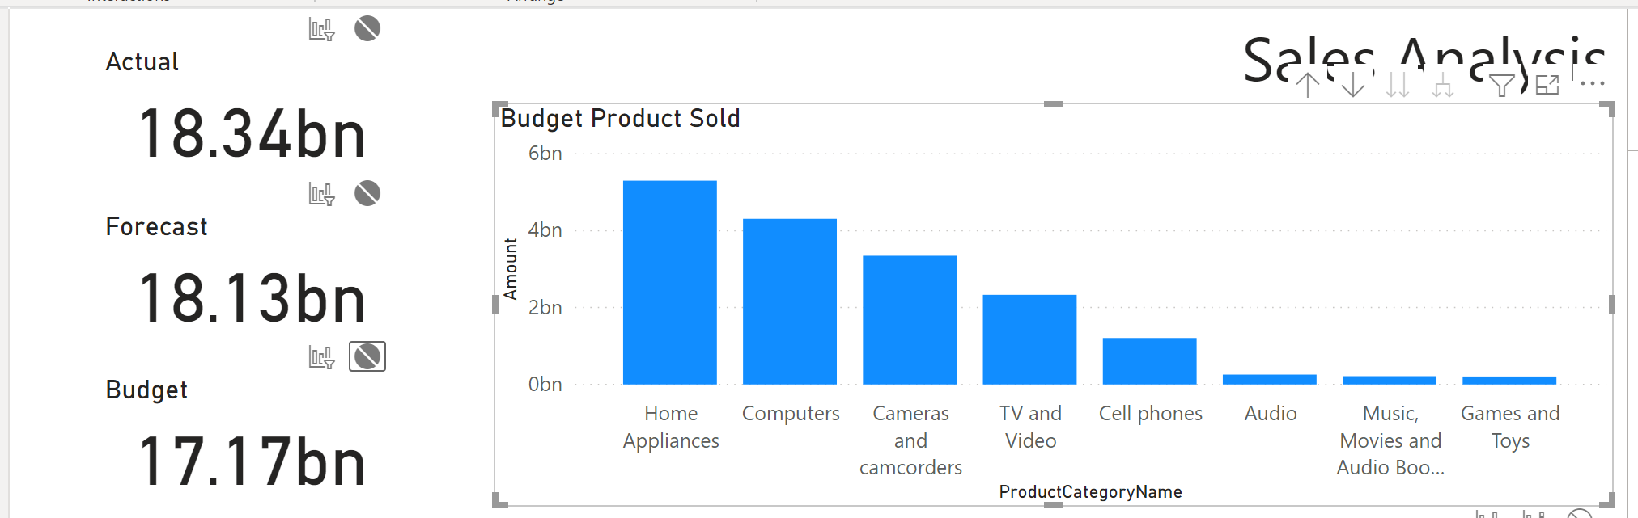



This means that any changes to the Budget Product Sold column bars will not affect the Actual, Forecast, and Budget cards. In other words, there are no interactions from the Budget Product Sold widget to the cards.

* Exit the interaction editing mode: click Edit interaction.

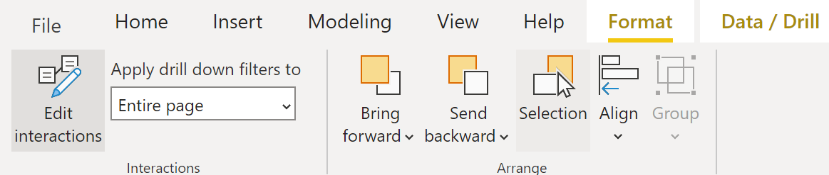

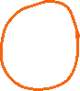

Edit interaction is now disabled and the circle icons are not visible.

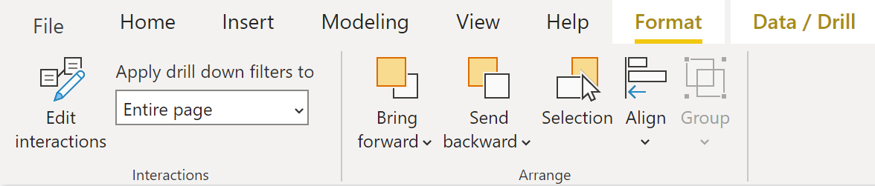

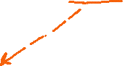

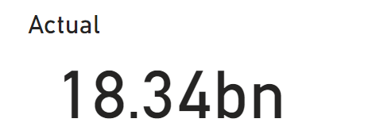



Click on Home Appliances bar--note the values of the cards.

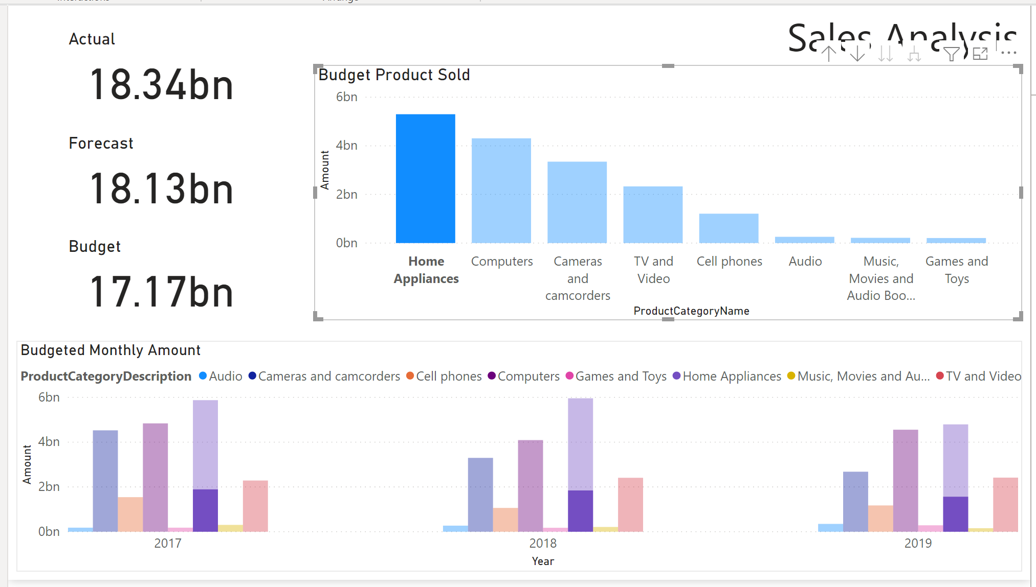

Click on Computers bar--note the values of the cards.

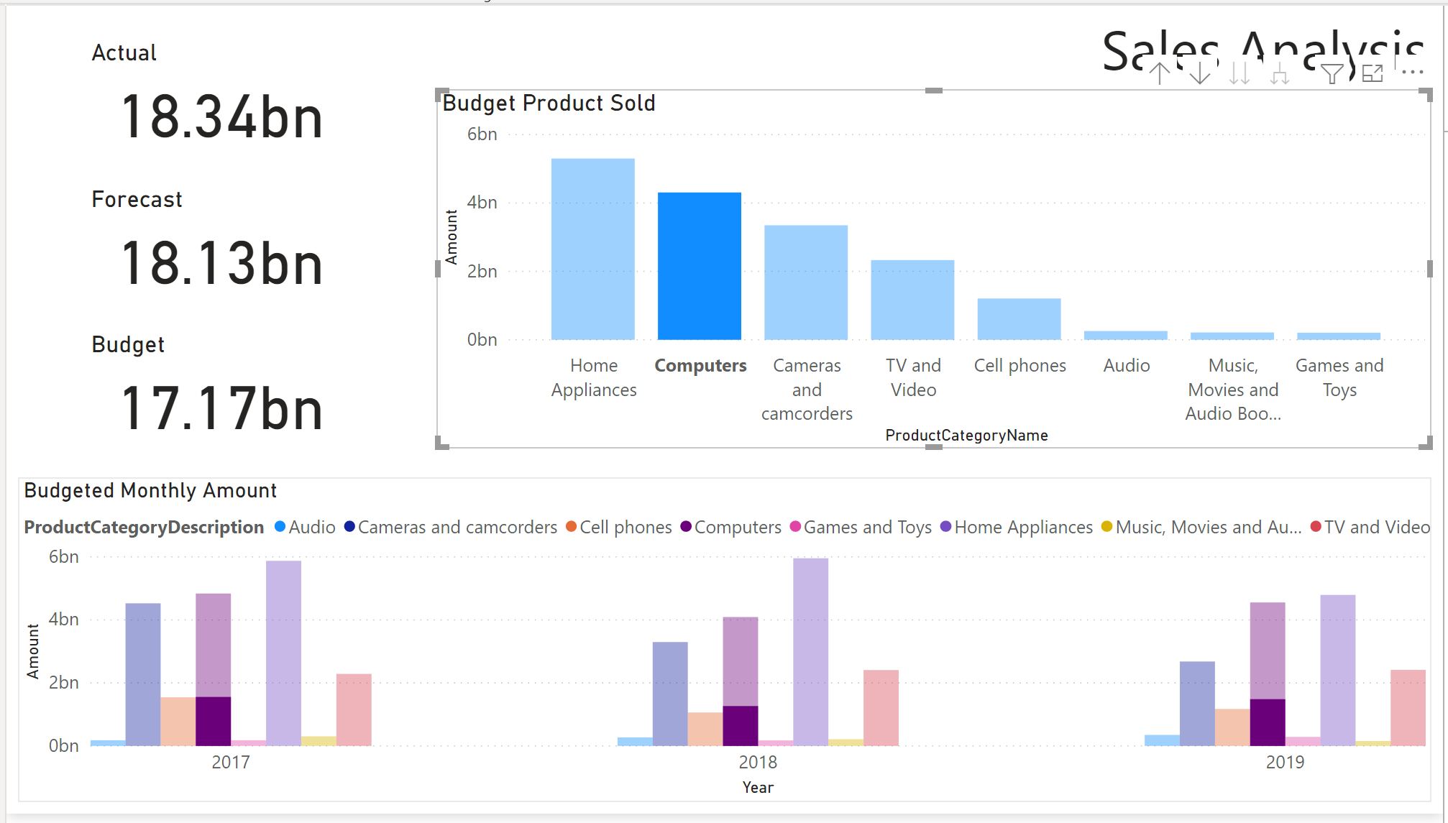

The cards’ values are static and not interacting with Budget Product Sold column bars. However, the Budgeted Monthly Amount clustered column chart still changes based on the changes from Budget Product Sold visuals because we did not turn off the interaction between the two visualization objects.

* Explore how the interactions work by selecting elements in other visuals and seeing how it affects the cards. For example, click on the 2017 cluster of Budgeted Monthly Amount and observe how the Actual, Forecast, and Budget cards’ values change.

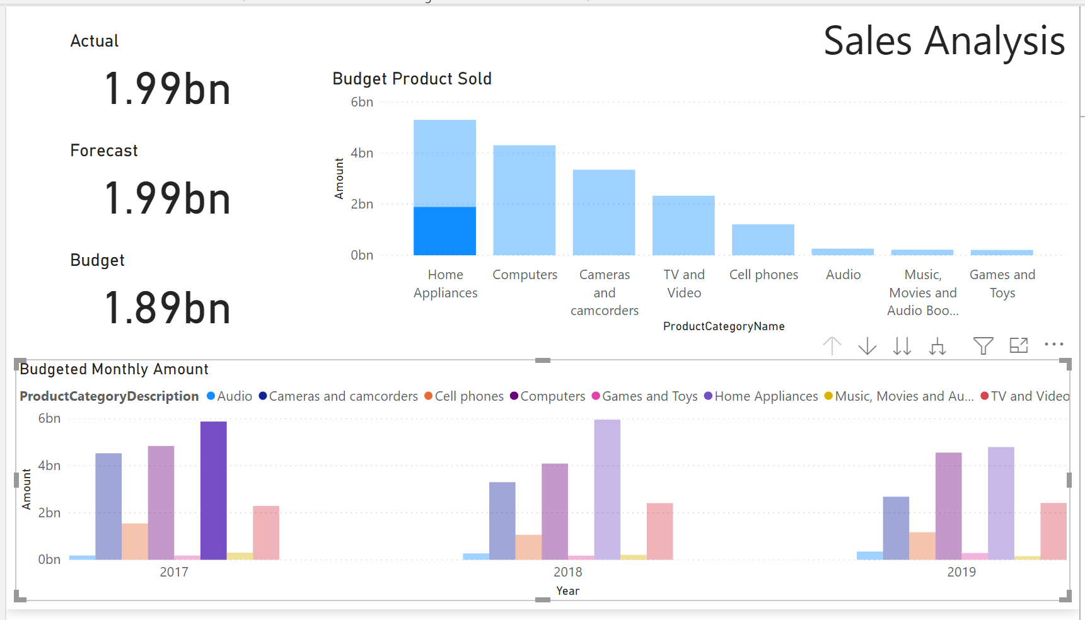



Why did the cards’ values change to changes in Budgeted Monthly Amount clustered column chart, but will not alter their values when bars from Budget Product Sold column chart is selected?

|  |
| --- |
| Because I only disabled the listener to the Budget Product Sold bar chart and not the Budgeted Monthly Amount chart. |

**Select the "TV and Video" bar in the "Budget Product Sold" chart. What is the value of the Budget card? (format example: ##.##bn)**

|  |
| --- |
| 17.17bn |

Please reposition your Report so that it would look like the dashboard below. Take a snapshot using Window's Snipping Tool. Make sure the encircled items are included. Place your image at the end of this document (after the example below) and submit this completed artifact to Canvas in Word format.  Please do not forget to save your work. Congratulations for getting this far!

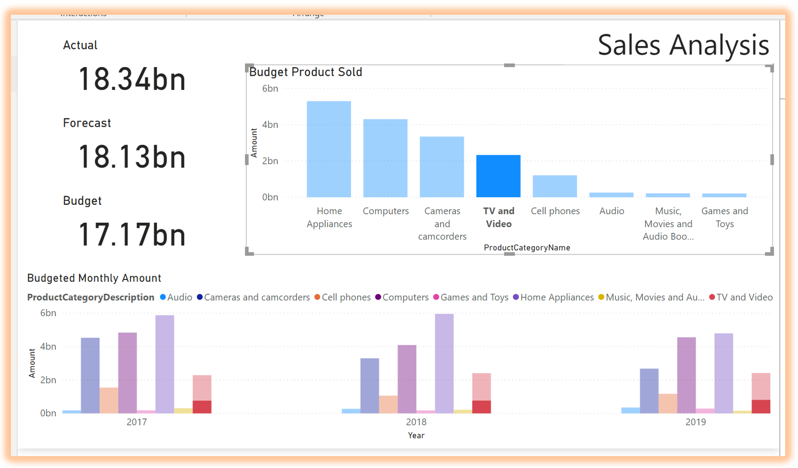

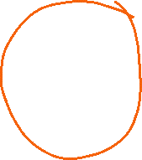

|  |
| --- |
| Please paste here your final dashboard. |